|  |  |  |  |  |
| --- | --- | --- | --- | --- |
|  | **Criteria** | **Grade claimed** | **Supporting arguments** | **Supporting evidence (refer to appendix if needed)** |
| **Basic** | Professional Behaviour | D | * As team leader it was imperative to maintain a professional manner to both the team and stakeholders. As such, I was respectful and supportive to all team members so that all stakeholders were informed the project position. | * Scheduled and hosted meetings with team, product owner and supervisor. * Being the main point of contact for the product owner to make suggestions for the project. * Note taking of future tasks. |
| D | * Ran all members through the way to commit changes to the project so that work does not impede on others. This includes preventing merge conflicts. * Added members to the team’s discussion, trello and Sharepoint. | * Created tasks and assigned each member accordingly so that member work is not impeding. * Set up worklog, attendance log and the database for the whole T1 2021 team. |
| Accountability (Worklogs) | D | * Now I am hitting approximately 30 hours of work towards the project, which adheres to the recommended 120 hours put towards this unit. | * Please refer to worklog image and link: [Work Log Reference](https://teams.microsoft.com/l/channel/19%3A4c4e3c303878481f9800937d71acb03b%40thread.tacv2/tab%3A%3Af38ef2d2-3788-4449-bbf7-09f5ae840ac8?groupId=d1dc0574-1c34-4e8f-97e9-838d1b7ce2dd&tenantId=d02378ec-1688-46d5-8540-1c28b5f470f6) |
| Attendance | D | * Now I have attended 100% of all meetings in a prompt fashion. | * Please refer to [Attendance Log](https://teams.microsoft.com/l/channel/19%3A4c4e3c303878481f9800937d71acb03b%40thread.tacv2/tab%3A%3A00730baf-f178-42a0-b08e-4a5570406df8?groupId=d1dc0574-1c34-4e8f-97e9-838d1b7ce2dd&tenantId=d02378ec-1688-46d5-8540-1c28b5f470f6). |
| Engagement | D | * Demonstrated commitment to the project by sharing new ideas to the team and planning future tasks for the project. * Completed tasks as per suggested by the product owner. | * Actively joining discord so that any members needing to talk or share ideas about the project can speak to myself. * Participated in future iteration note taking and trello task creation and assigning of members. |
| **Core** | Communication | D | * Demonstrated excellence in sharing the project plans to the product owner so we can get his feedback. * Shared design information in a form of a style guide, so that all new onboarded juniors can get a clear idea of the themes of the Island. | * Create [The Island Style Guide](https://trello-attachments.s3.amazonaws.com/5f280aa170b6fa0bb0792d0e/6053136c1b2f3884f30337ae/d5c400b17fc88c5797f518c26efd1e93/Escape_Room_-_The_Island_Style_Guide.pdf) (Design Team) |
| Teamwork | HD | * Provided outstanding support to other seniors & juniors, by providing constructive feedback and showed support when they had questions for answering. * Jonathan wanted to upskill in audio creation for the project, I researched the originally used software that was used by previous members and shared it with him, so he uses the compatible platforms. | * Please refer off discussion thread with Jonathan Vieri. |
| Process | D | * Demonstrated excellence when running the juniors through how to follow the systematic processes of committing, branch switching, adding in attendance, and adding hours to worklog. * Committed several tasks in the correct process, such as creating a task in the trello board, assigning the task to me with the design label, committing the complete task to correct branch, then filling out the worklog. | * Please refer to Trello, Bitbucket/SourceTree and Worklog. |
| Product | D | * Consistently contributed to multiple project deliverables such as the creation of a new logo, creating attacker indicators, created style guide for game, Created new graphics for sail Buttons in 3 different stages. | * Please refer off trello board to see completed / For review tasks. |
| D | * Completed several important slides to review within the panel prestation. * Prepared script to speak about the project management part of the expert panel demo, and the design part of it too. | * Please refer off slides for project demo. |
| IT Skills | D | * Demonstrated excellence in creating graphics and images to be used in game that represents relevant discipline around my course and degree. | * Created new sail buttons, Animal indicators, style guide. All can be found in trello board. * Added in custom scripts into sprites to skip and return to specific pages in play, escape, and death scenes. |
| **Advanced** | Self-Awareness | D | * I identified ways to implement my design skills, particularly on easing the UI. I added in buttons that makes the user experience easier to navigate between scenes. * Having design strengths, I was able to further improve the UI. | * Added in custom scripts into sprites to skip and return to specific pages in play, escape, and death scenes. |
| Project Management | HD | * Created, assigned and commented on tasks in the trello board so that members of the team are well aware who is to complete a task, what team does that member belong to (design or functionality), and if anything can be refined to improve the game further. | * Please refer off trello discussion with Anthony in appendix. |
| Mentoring | D | * Have contributed to many mentoring lessons with the likes of Andrew, Jonathan, and Jack. These members have stayed back in meetings so that I can teach them how to follow the process of committing work to the repository. | * I have suggested several times that I will be in the discord in case anyone needs help with anything. This is screenshotted in the appendix. |

In the next iteration I plan to have all the seniors and juniors working together to provide further mentoring. Ideally it would be great to have the juniors using their initiative to create their own trello cards and assigning each member accordingly based off the design or functionality team. Additionally, I plan to redesign all the buttons so that the buttons appear more dynamic in nature and reflect 3d text, sprites, and ambient noises on click. I would also want to work with Jack to better reduce the file size of the island pan, escape and death cinematics. I would also be planning on working with Sean to have the health bars glowing when in the critical region, as well as refining the critical message on screen for low resources. Also I am hoping to work towards creating a how-to-play video so that a new user can jump straight into a game, watch the video and play with ease.

# Appendices (if any)

* [**Work Log Reference:**](https://teams.microsoft.com/l/channel/19%3A4c4e3c303878481f9800937d71acb03b%40thread.tacv2/tab%3A%3Af38ef2d2-3788-4449-bbf7-09f5ae840ac8?groupId=d1dc0574-1c34-4e8f-97e9-838d1b7ce2dd&tenantId=d02378ec-1688-46d5-8540-1c28b5f470f6)  
  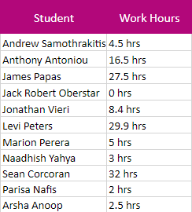
* [**Group Attendance Log 2021:**](https://teams.microsoft.com/l/channel/19%3A4c4e3c303878481f9800937d71acb03b%40thread.tacv2/tab%3A%3A00730baf-f178-42a0-b08e-4a5570406df8?groupId=d1dc0574-1c34-4e8f-97e9-838d1b7ce2dd&tenantId=d02378ec-1688-46d5-8540-1c28b5f470f6)   
    
  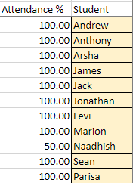
* [**Discord Channel with product Owner**](https://discord.gg/HdTcfMEC)**:**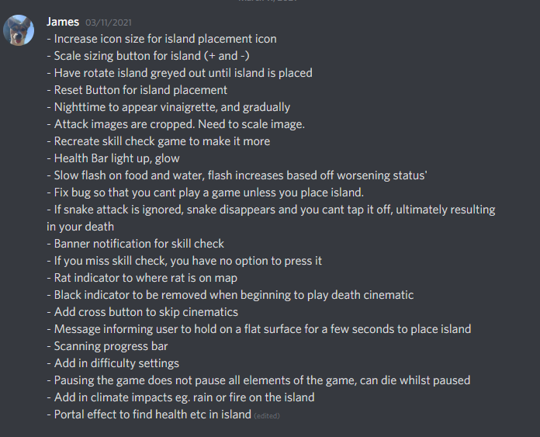
* [**Trello Board**](https://trello.com/b/gNlzJ7ax/escape-room-game-the-island-trello)**:  
  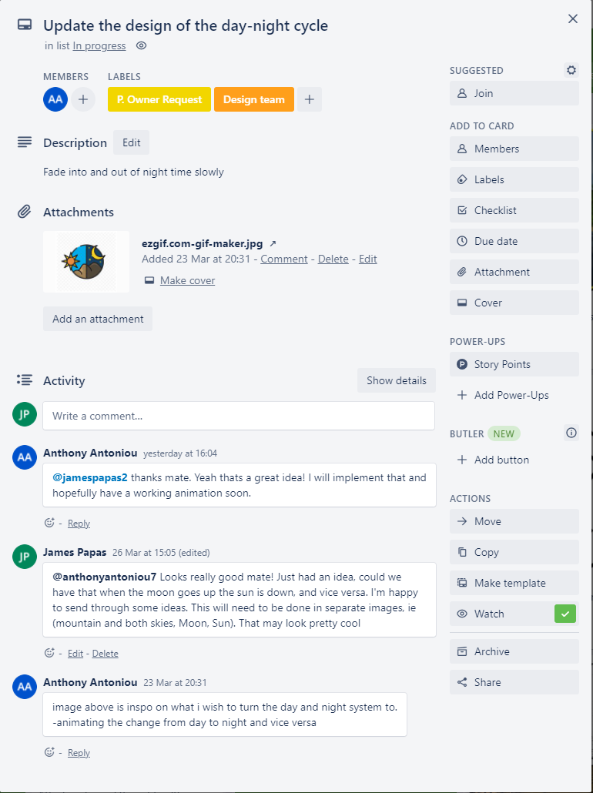  
  For Review:  
  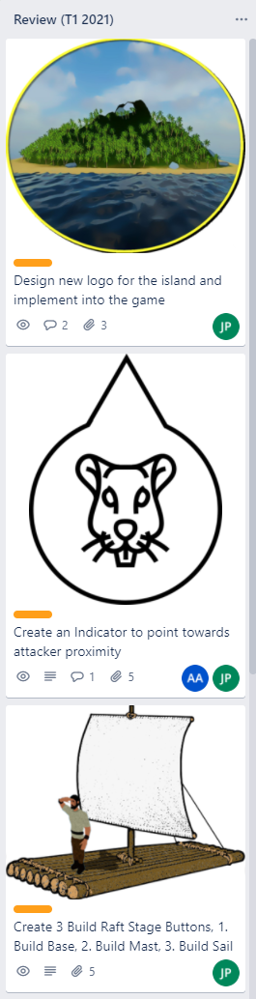**
* [Create ‘The Island Style Guide’ for design team](https://trello-attachments.s3.amazonaws.com/5f280aa170b6fa0bb0792d0e/6053136c1b2f3884f30337ae/d5c400b17fc88c5797f518c26efd1e93/Escape_Room_-_The_Island_Style_Guide.pdf):  
  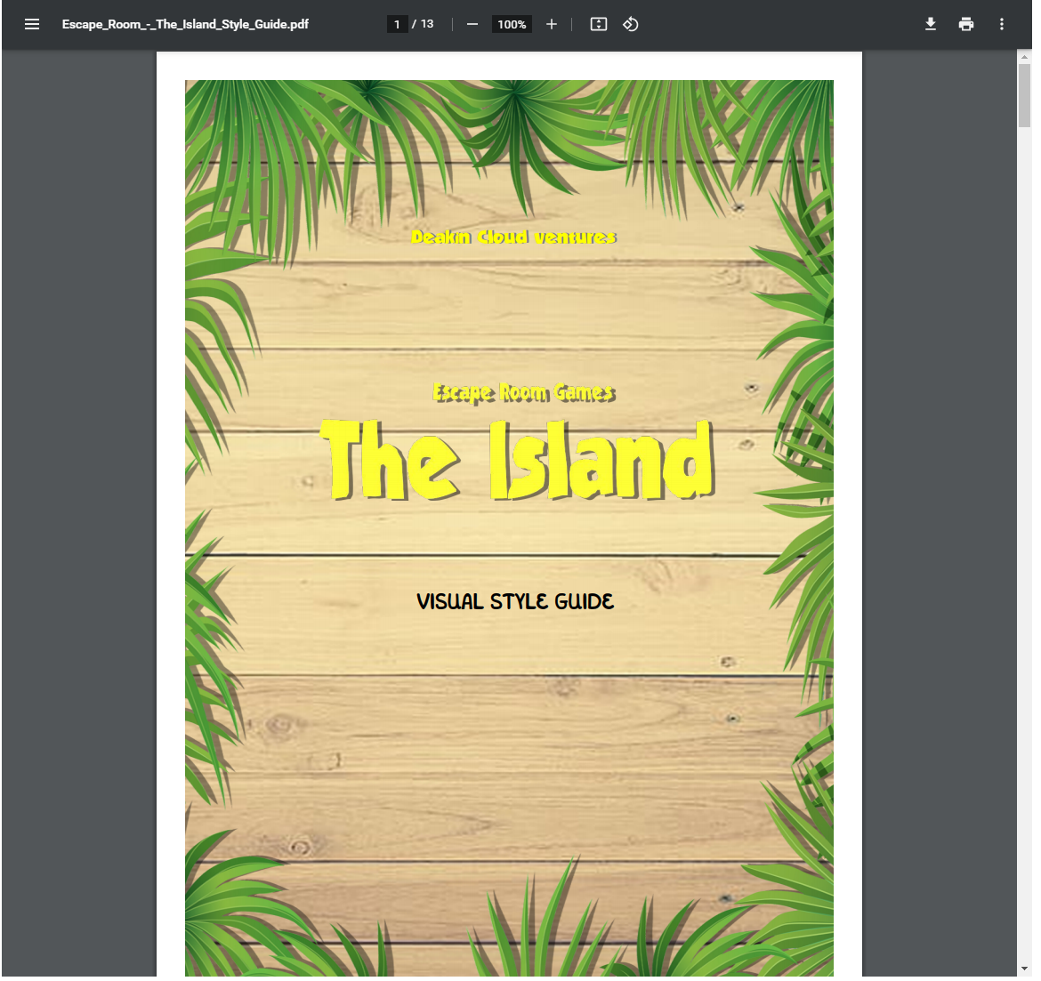
* Discussion Thread in MS Teams with Jonathan Vieri:  
  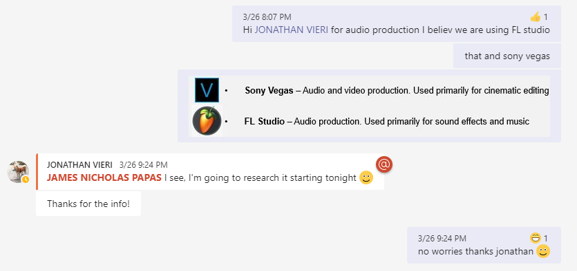
* SourceTree Reference:   
  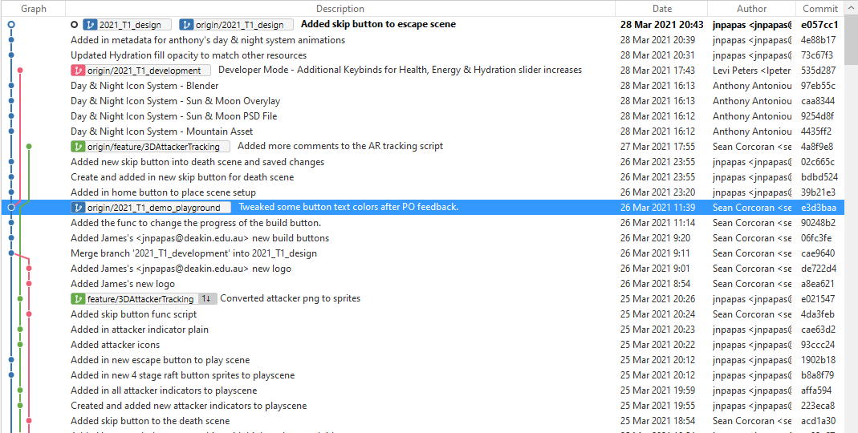
* [Project Demo – Iteration 0 Slides](https://teams.microsoft.com/l/file/7A04496A-0D06-4030-A1D1-948B25280049?tenantId=d02378ec-1688-46d5-8540-1c28b5f470f6&fileType=pptx&objectUrl=https%3A%2F%2Fdeakin365.sharepoint.com%2Fsites%2FDeakinCloudVentures%2FShared%20Documents%2FEscape%20Room%20Games%20-%20The%20Island%2FTrimester%201%202021%20-%20Work%2FIteration%20Presentations%2FIteration%200.pptx&baseUrl=https%3A%2F%2Fdeakin365.sharepoint.com%2Fsites%2FDeakinCloudVentures&serviceName=teams&threadId=19:4c4e3c303878481f9800937d71acb03b@thread.tacv2&groupId=d1dc0574-1c34-4e8f-97e9-838d1b7ce2dd)
* Discussion with other Seniors:   
  